**Replication and Cost Reduction using Azure SQL Server Database**

**Introduction**

Fabrikam is an MNC who is Migrating to Microsoft Azure form on-premises. They are going to migrate their database services to the Azure and followed by that their app services and big data services as well. Before performing the migration of their database workloads from on-premise to Azure, they are looking to understand the replication mechanisms, security features, hybrid database environment implementation and the ease of deployment that can be done in Azure SQL database environment. Hence, Fabrikam is using a set of scenarios to deploy database service in Azure and to deploy all the offerings provided by Microsoft Azure SQL Database. The SQL database is being deployed and followed by that replication , failover, synchronization of data to on-premises will be done.

**Prerequisites**

To perform this demo user must have valid Azure subscription and some knowledge on Azure SQL Database, replication.

**Demo**

**Deploying Azure SQL Database**

Log-in to Azure portal with your Azure account using [www.portal.azure.com](http://www.portal.azure.com). In Azure portal click on **+Create a new resource>Database>SQL Database**.

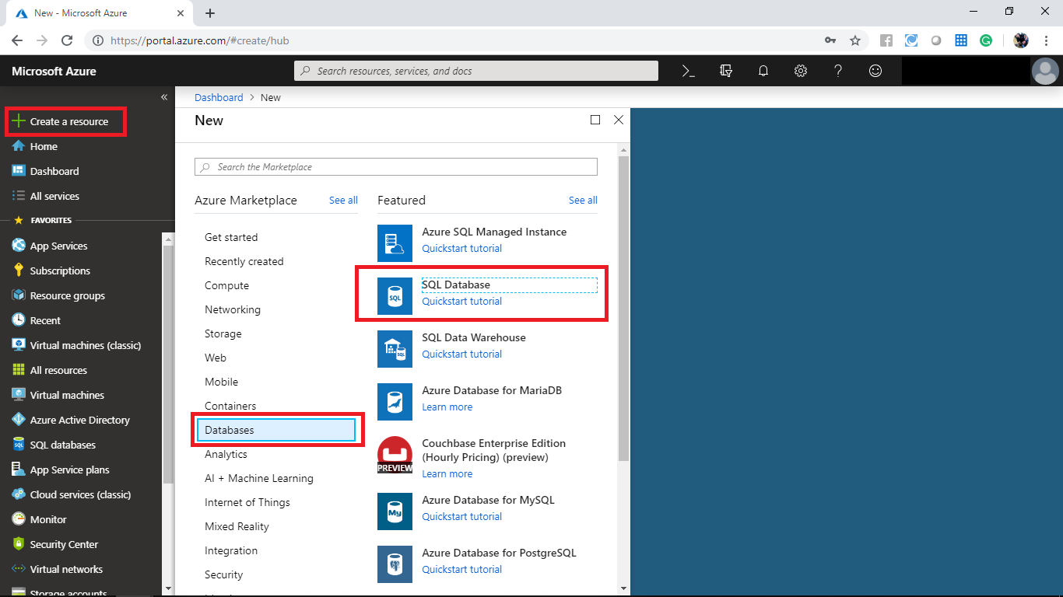

In the create SQL Database panel deploy a SQL Database with following configurations.

* Subscription: Select a valid subscription
* Resource group: Create a new resource group **SQL**
* Database name: fabrikamdb
* Server: Create a new server with following settings
* Server name: fabrikamserver
* Server admin log-in: fabrikamuser
* Password: For your choice
* Location: Select a valid location
* Want to use elastic pool: No
* Compute + Storage: Standard S0

After configuring these settings click on additional settings.

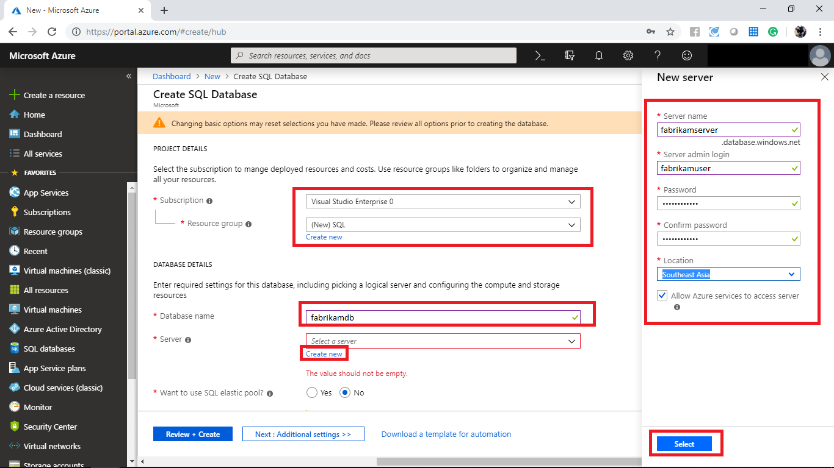

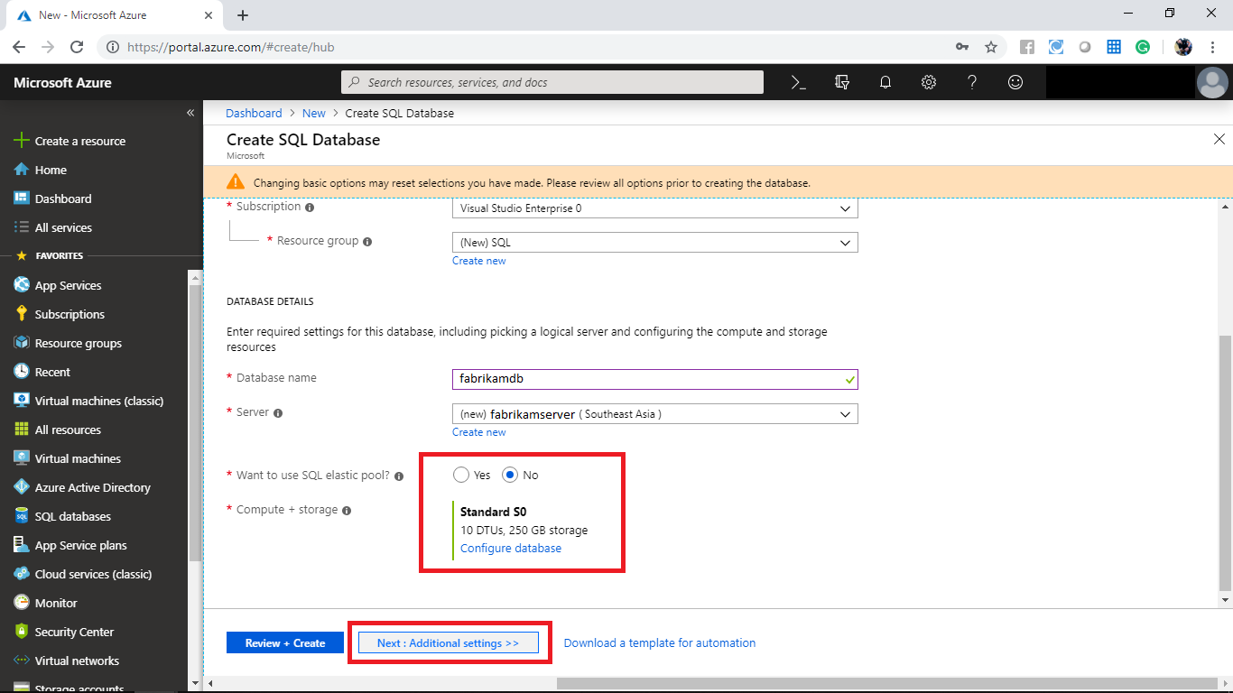

In the **Additional settings** panel set the use existing data to **Simple** and click on **Review + Create**.

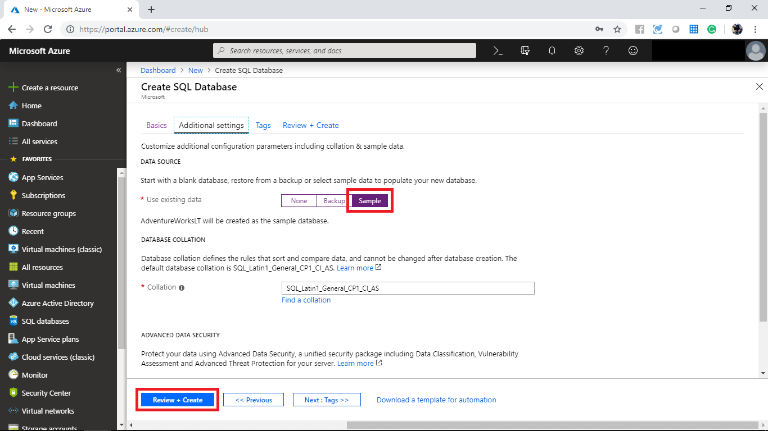

When it prompts click on create.

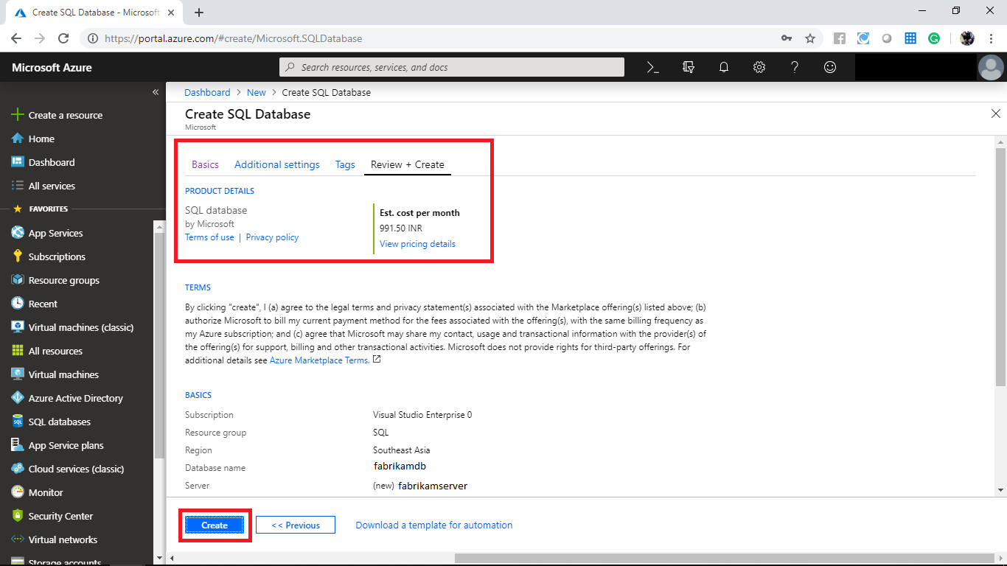

Wait until the deployment completes. After the deployment completes navigate to the created resource.

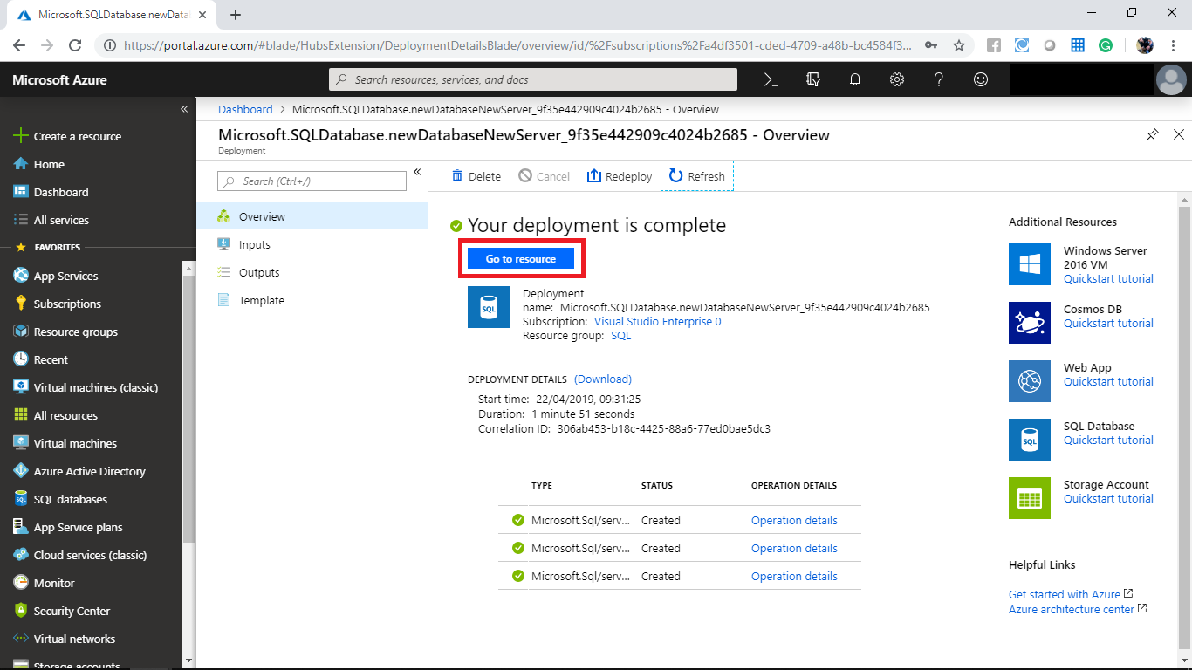

In the overview page of SQL Database note the server name you will need that for the upcoming steps and click on **Elastic pool**.

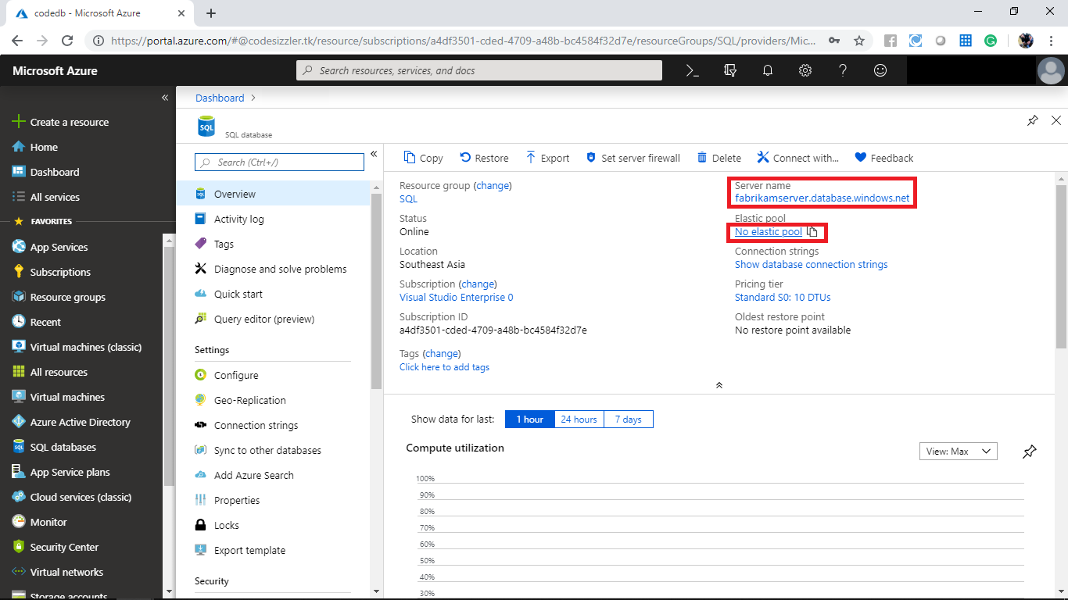

When it prompts click on **+New pool**.

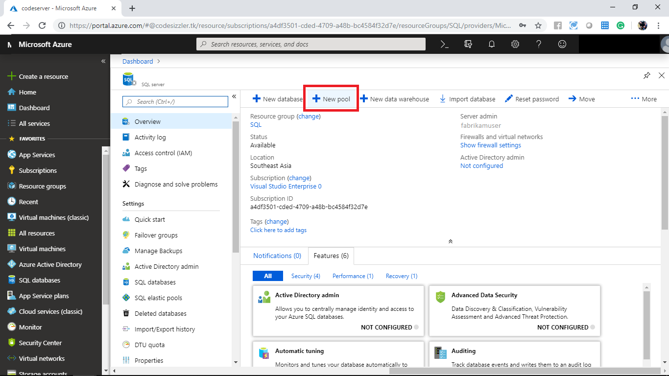

Create a new elastic pool with following settings and click on ok.

* Name: fabrikampool
* Configure pool: Default

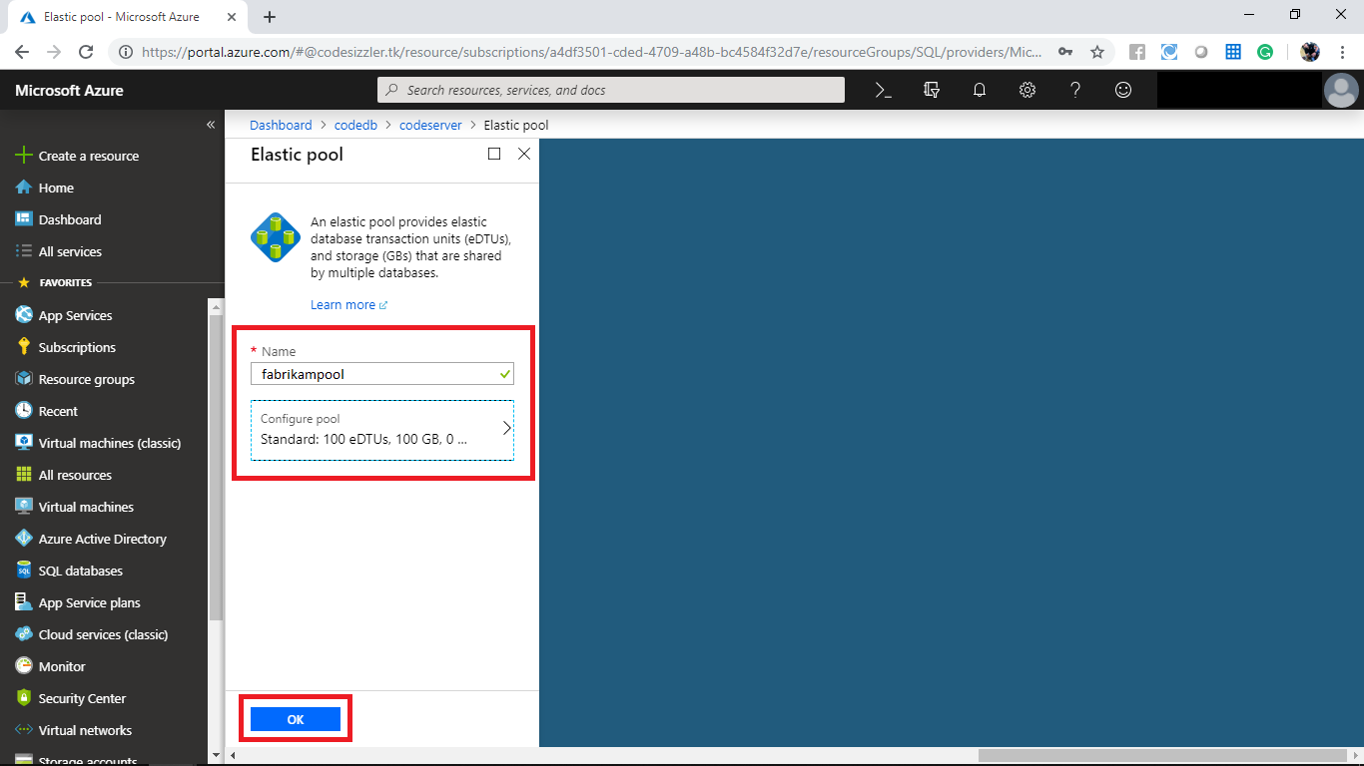

After the deployment completes navigate to the created resource.

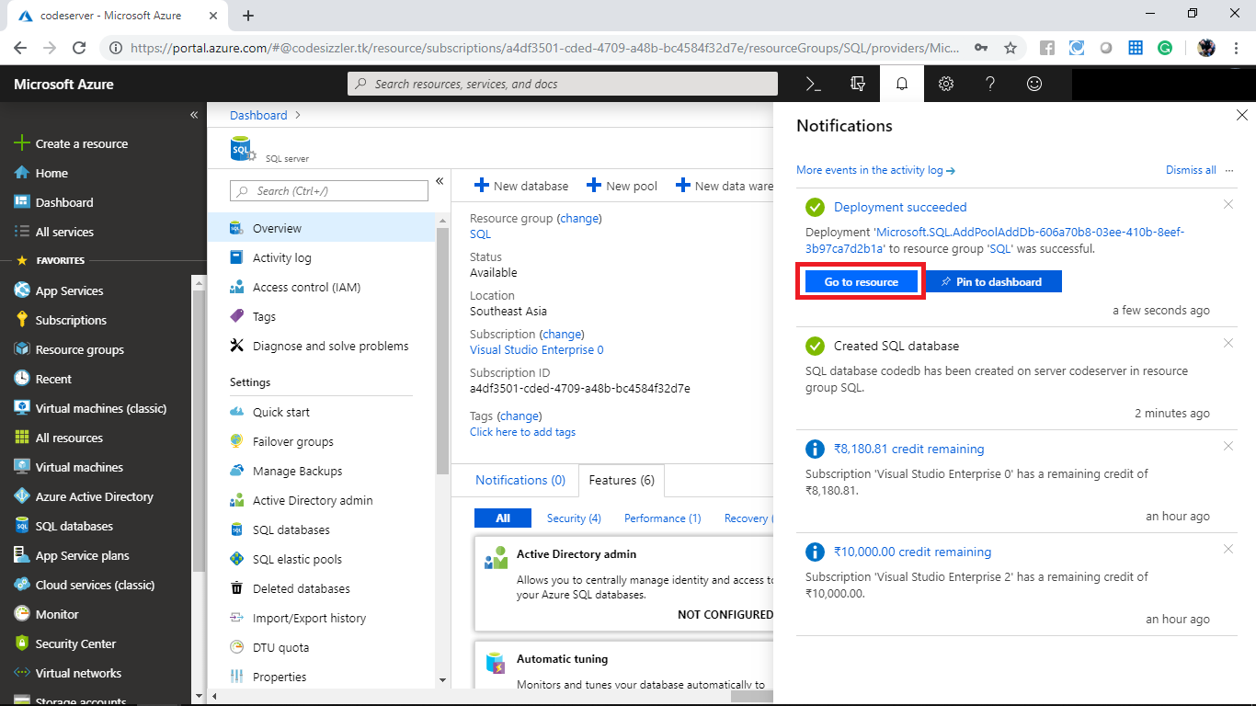

In the fabrikampool overview panel click on **Configure**.

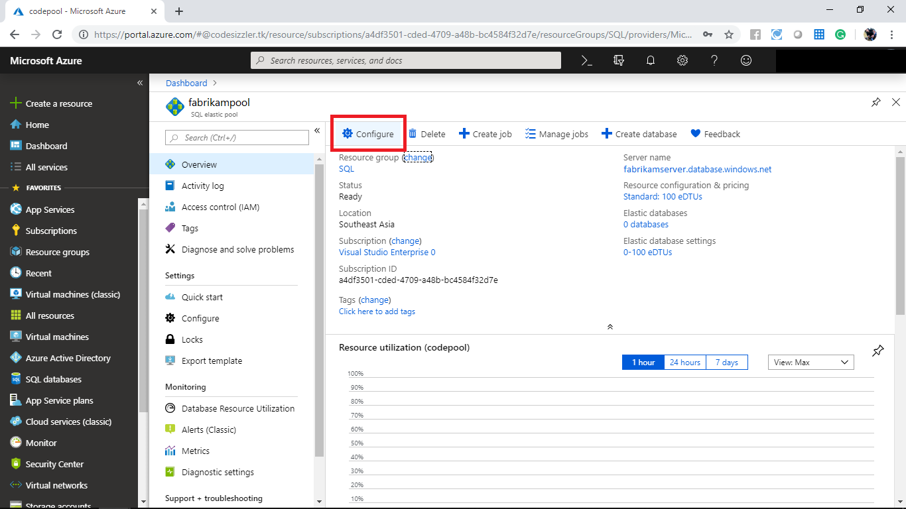

In the configure panel navigate to database and click on **+Add database**.

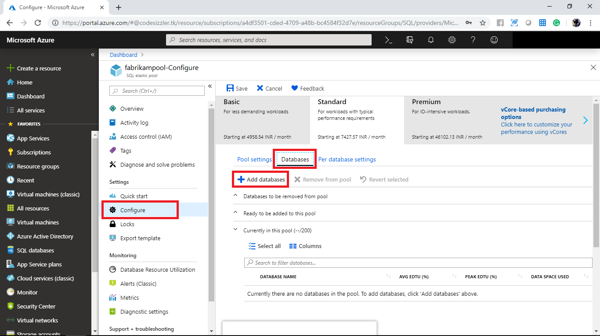

When it prompts select the **fabrikamdb** and click on apply.

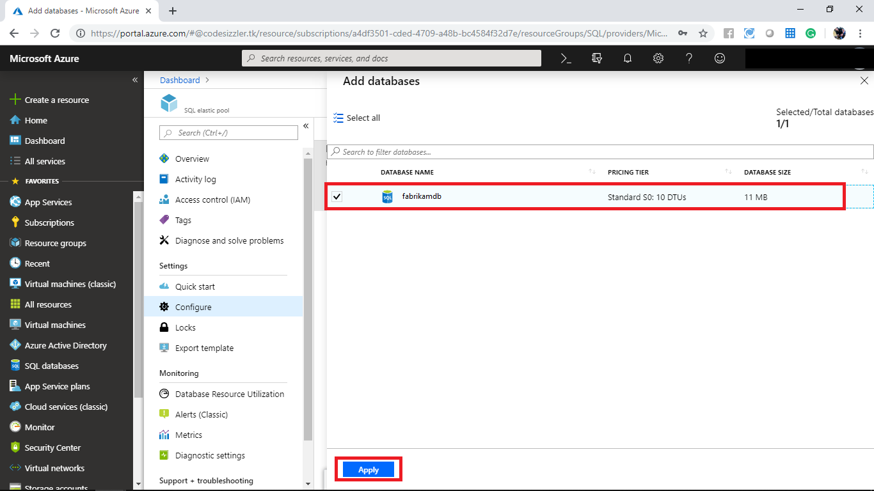

Click on save to save the changes that you made.

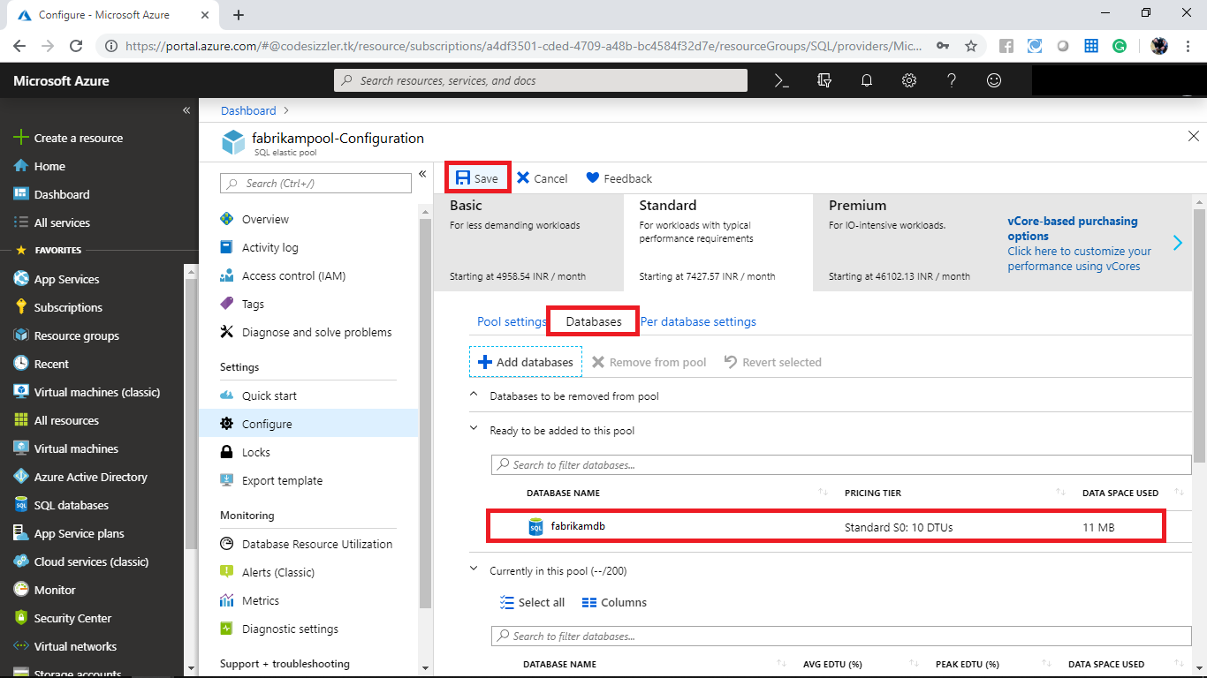

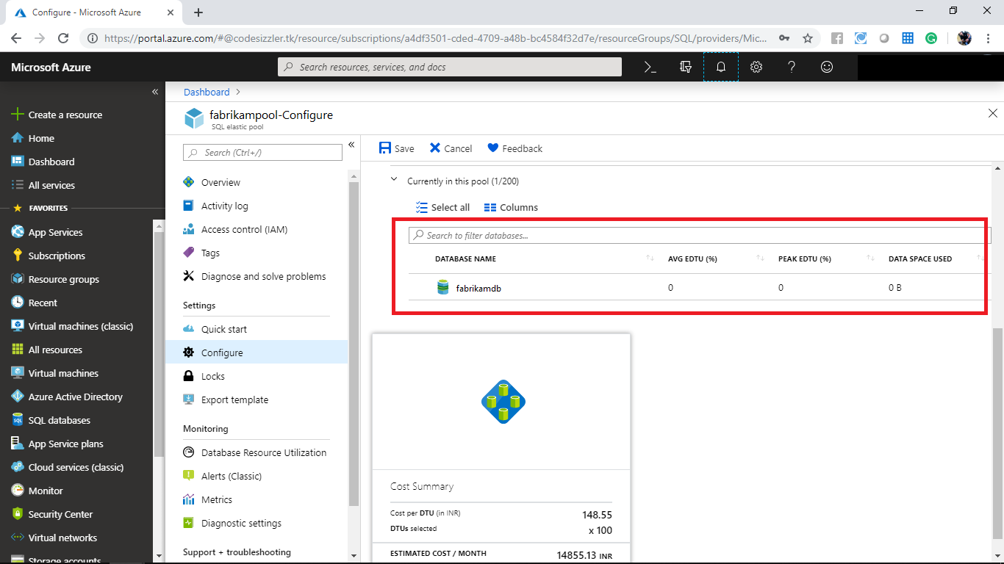

Navigate to pre-database settings to configure the number of DTUs.

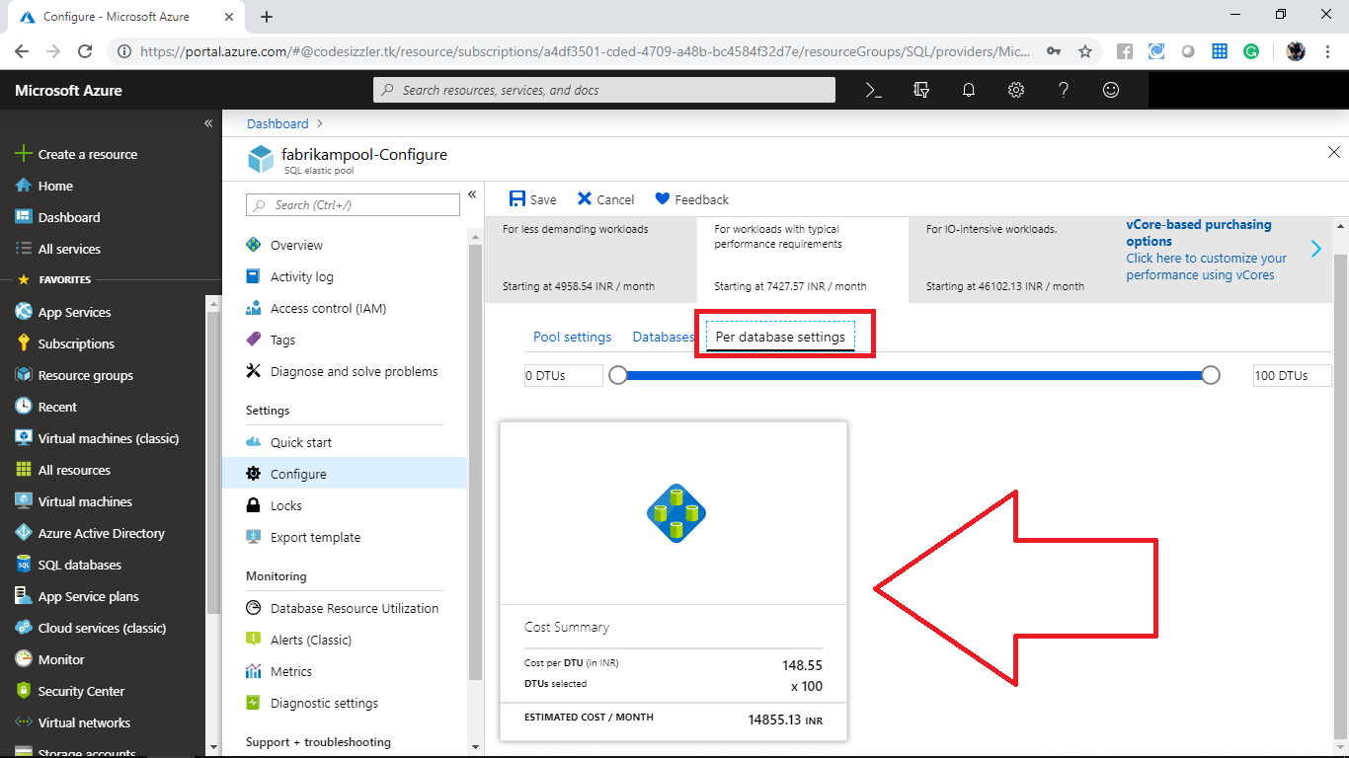

**Configuring Geo-Replication for Azure SQL Database**

In Azure portal click on **SQL Database** from the left side menu and select the SQL Database that you created.

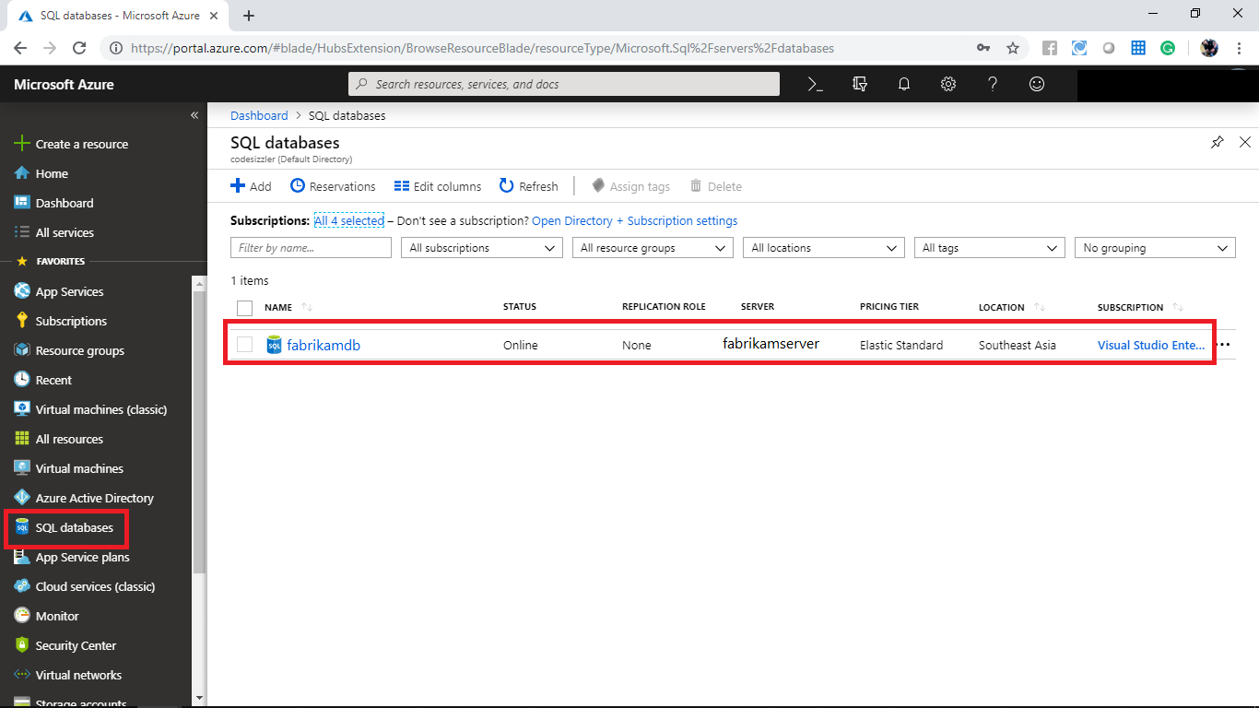

In the fabrikamdb SQL Database panel click on **Geo-Replication**.

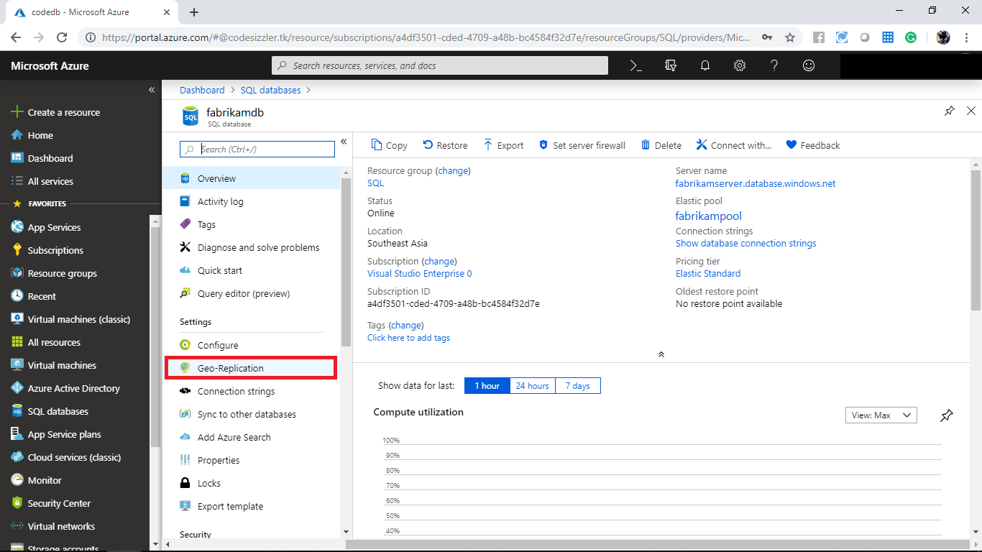

Note the Note that the primary and secondary region. You can see that the secondary region is not yet configured.

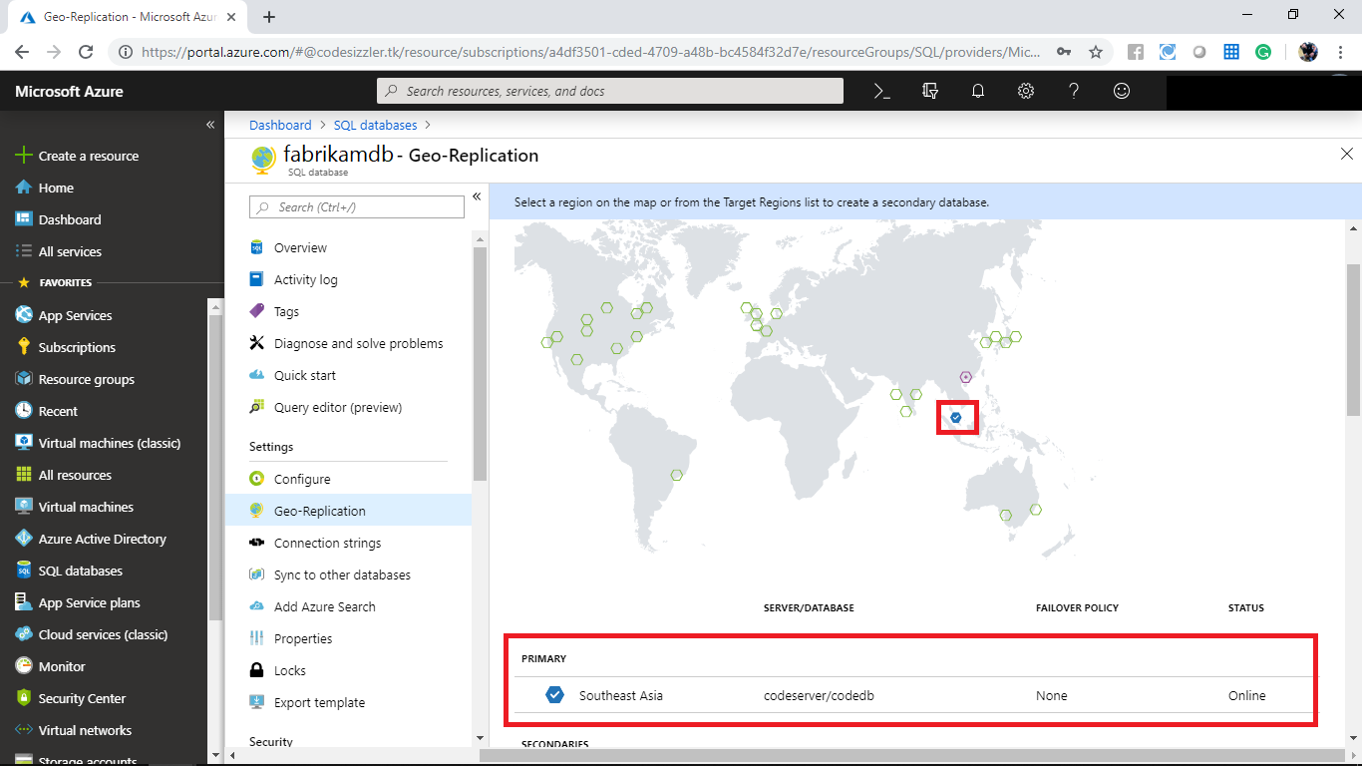

Select any of the valid region from the target region to create the secondary region.

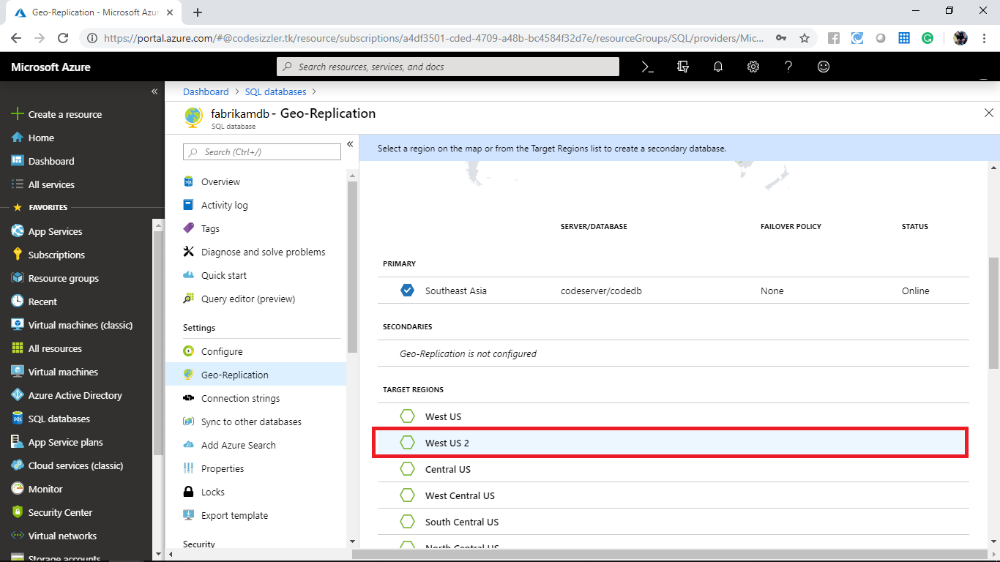

When it prompts provide the below configurations and click on ok.

* Target server
* Server name: fabrikamserverwest
* Server admin log-in: FabrikamsUser
* Password: for your choice
* Pricing tier: Standard S3

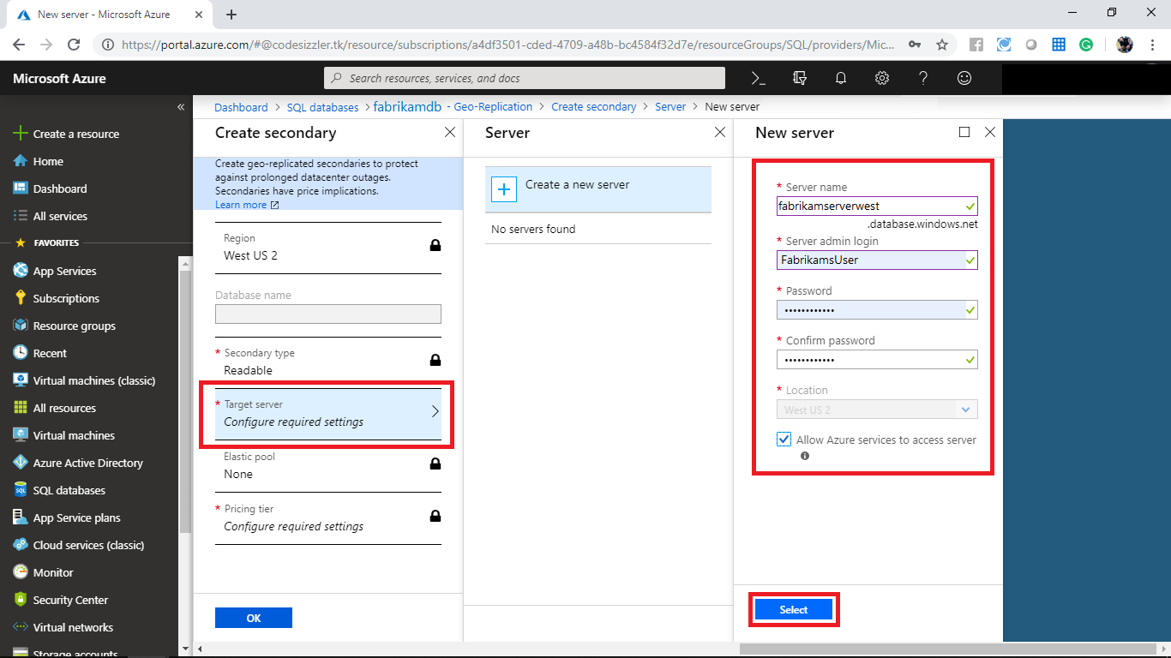

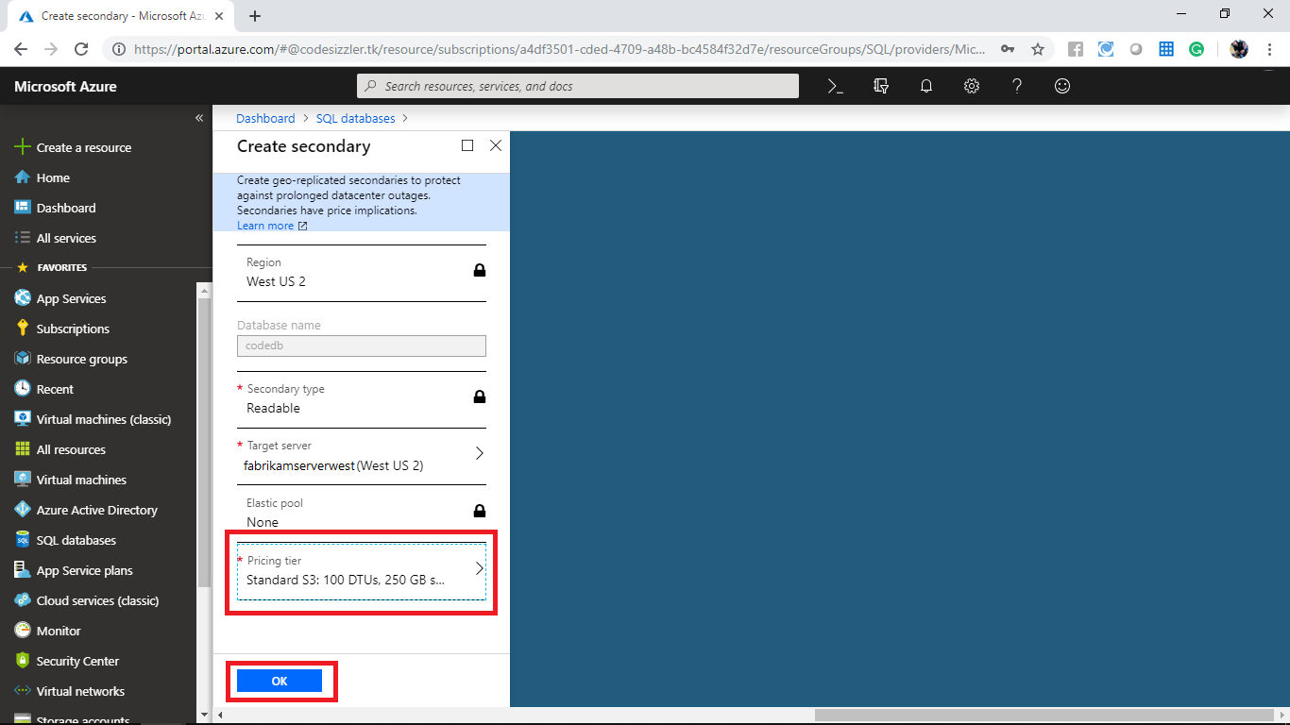

The dotted lie shows that the data is replicating from primary region to secondary region.

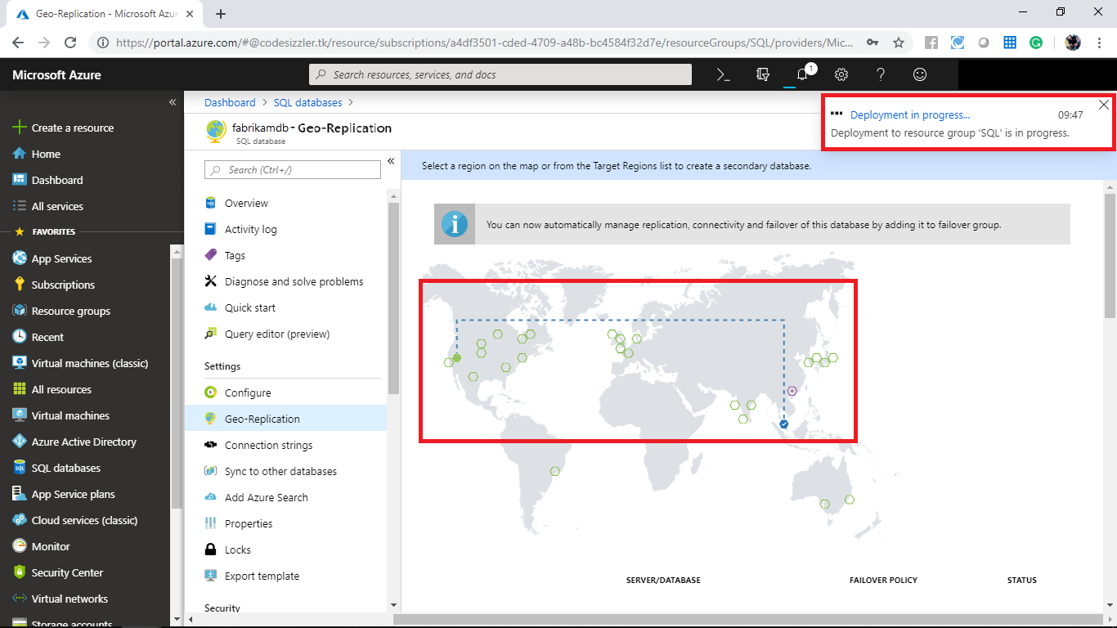

When it changes to normal line form dotted line it indicates that the data are replicated from primary region to secondary region.

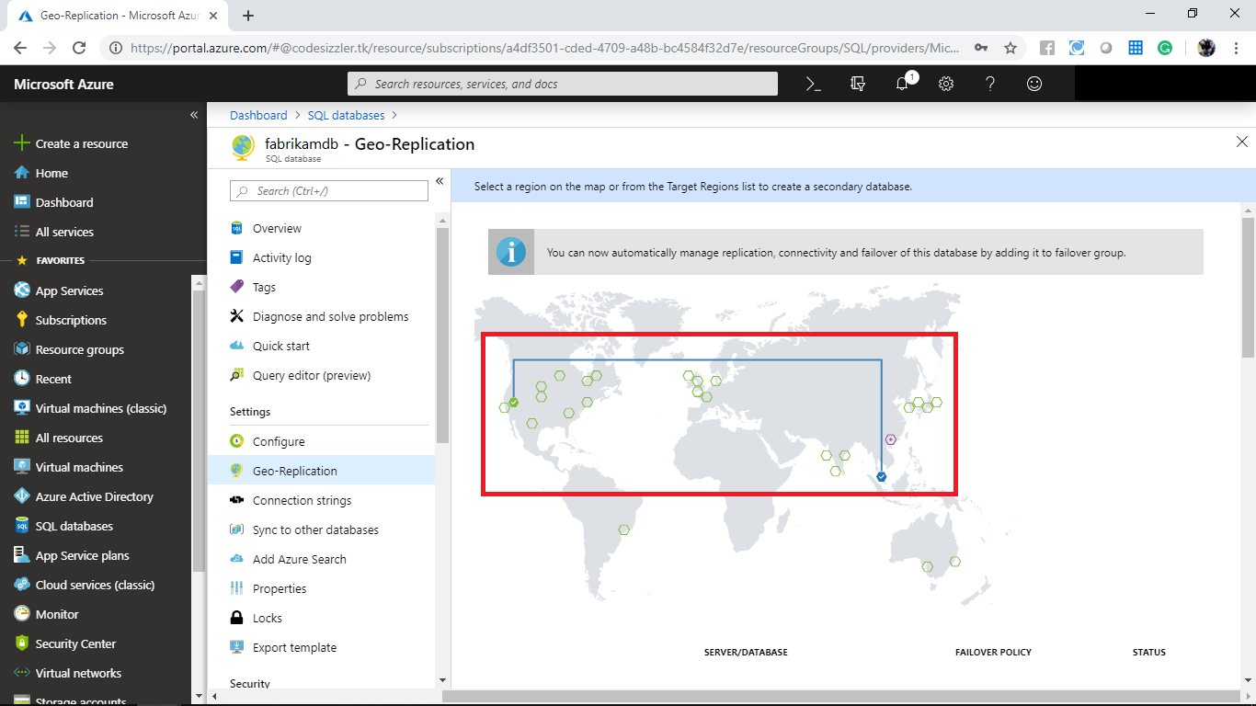

Click on the three dots on secondary region and **Forced Failover**. When it prompts click on yes.

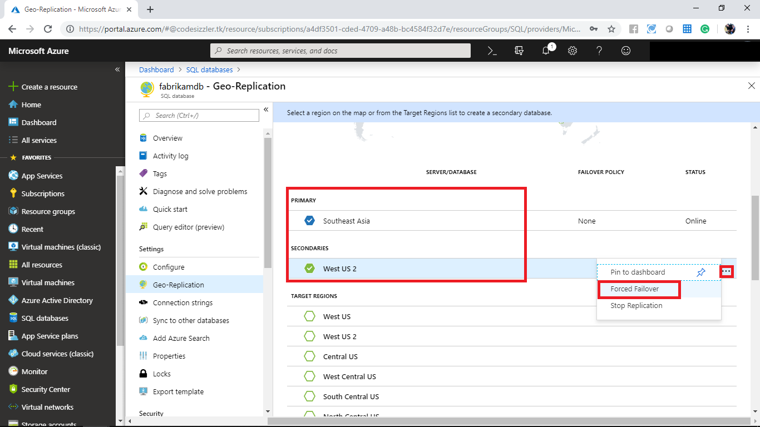

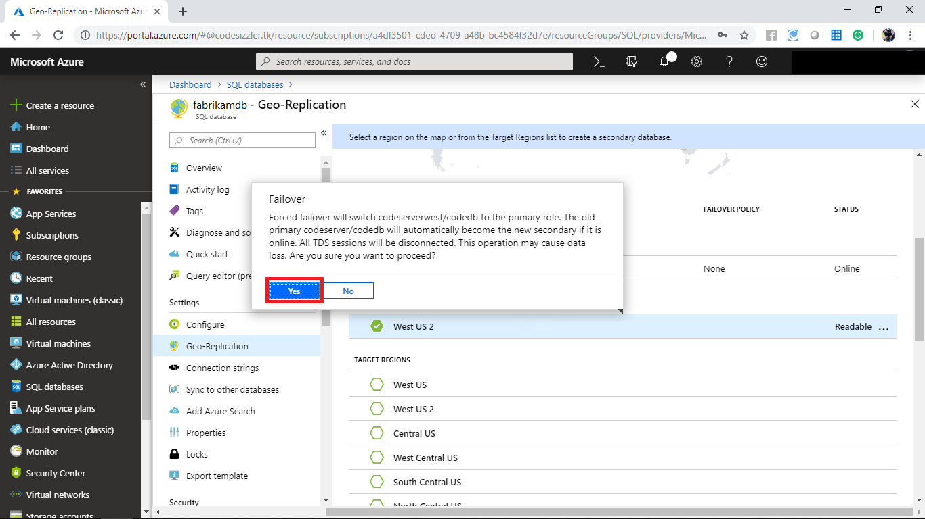

It will start again to replicate the data. Wait until it completes. Note that the primary region changes to secondary region.

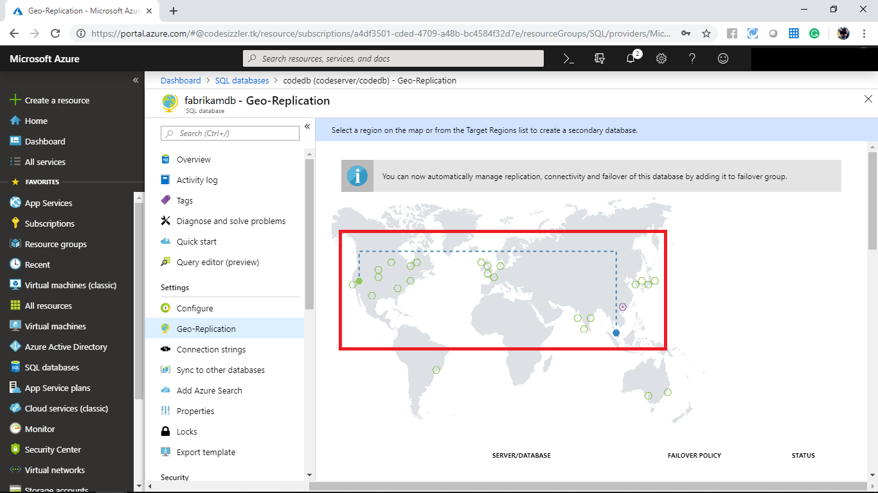

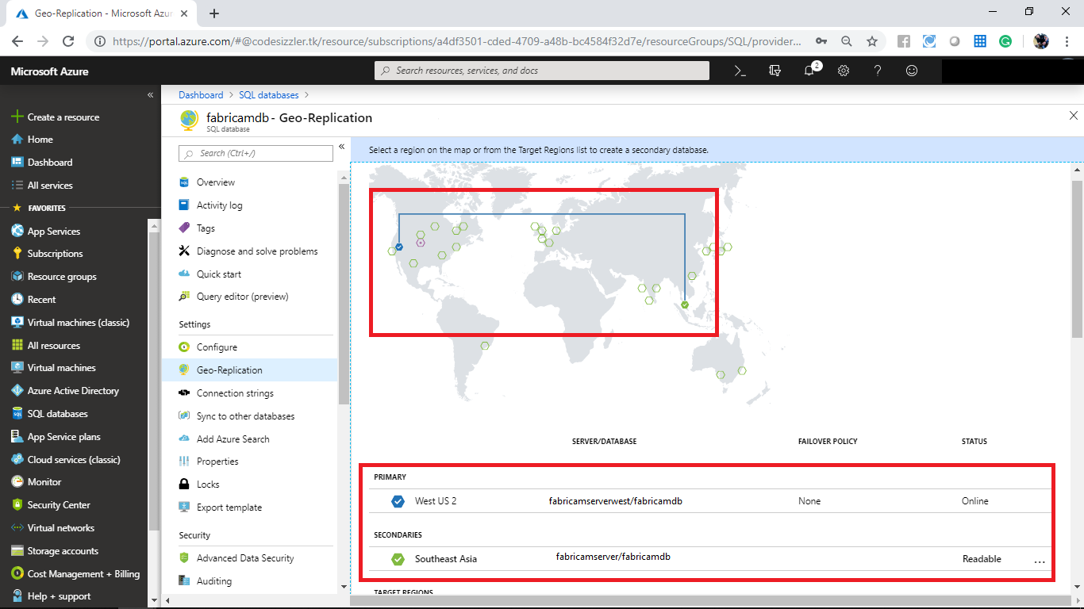

Click on the three dots of secondary region and select stop replication. When it prompts click on yes.

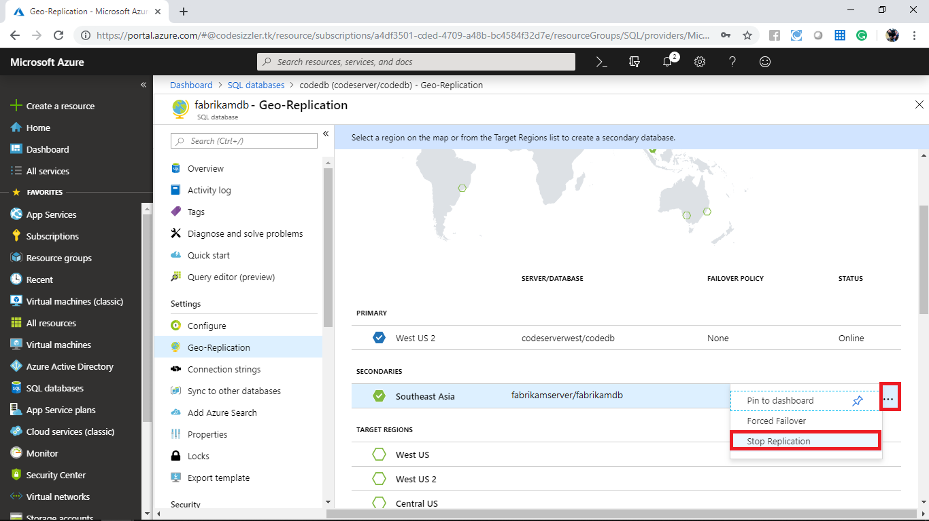

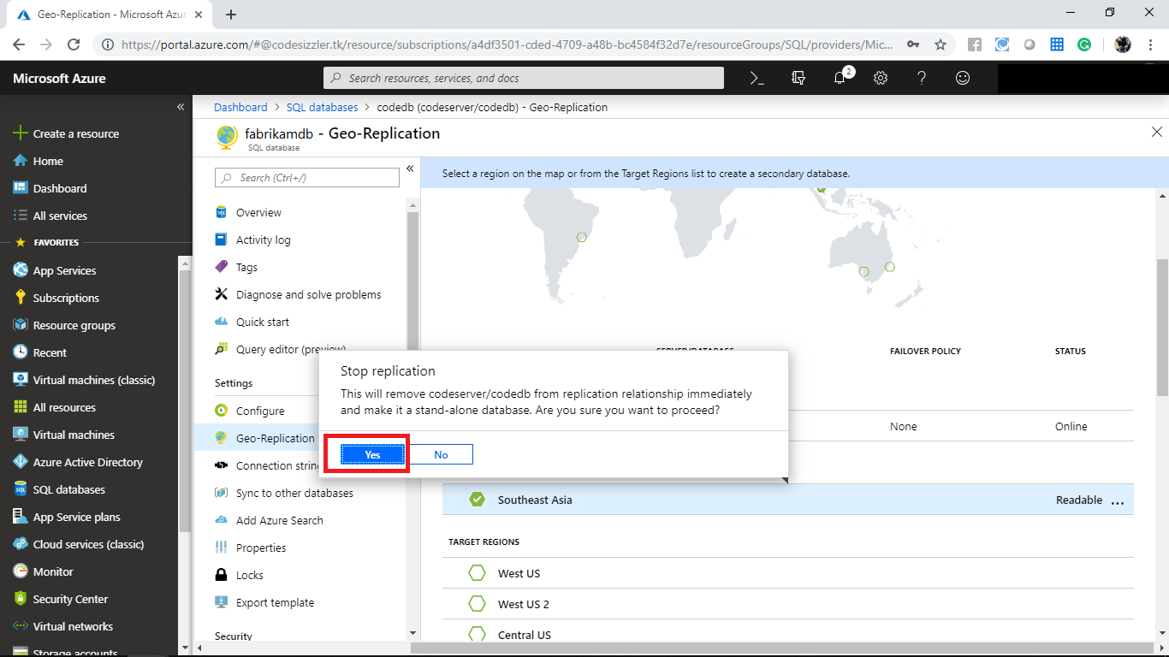

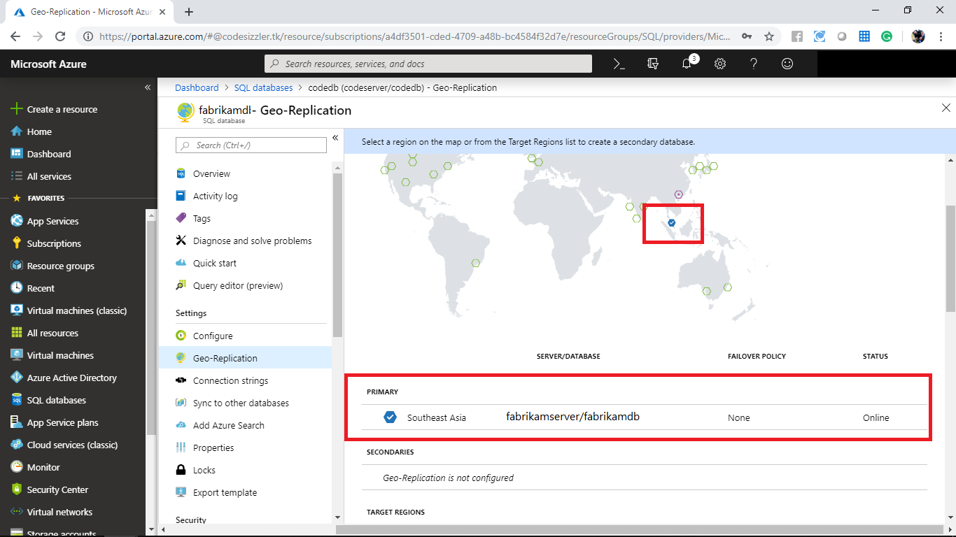

**Configuring Sync group for Azure SQL Database**

Navigate to **Sync to other devices** of **fabrikamdbdb** and click on **+New Sync group**.

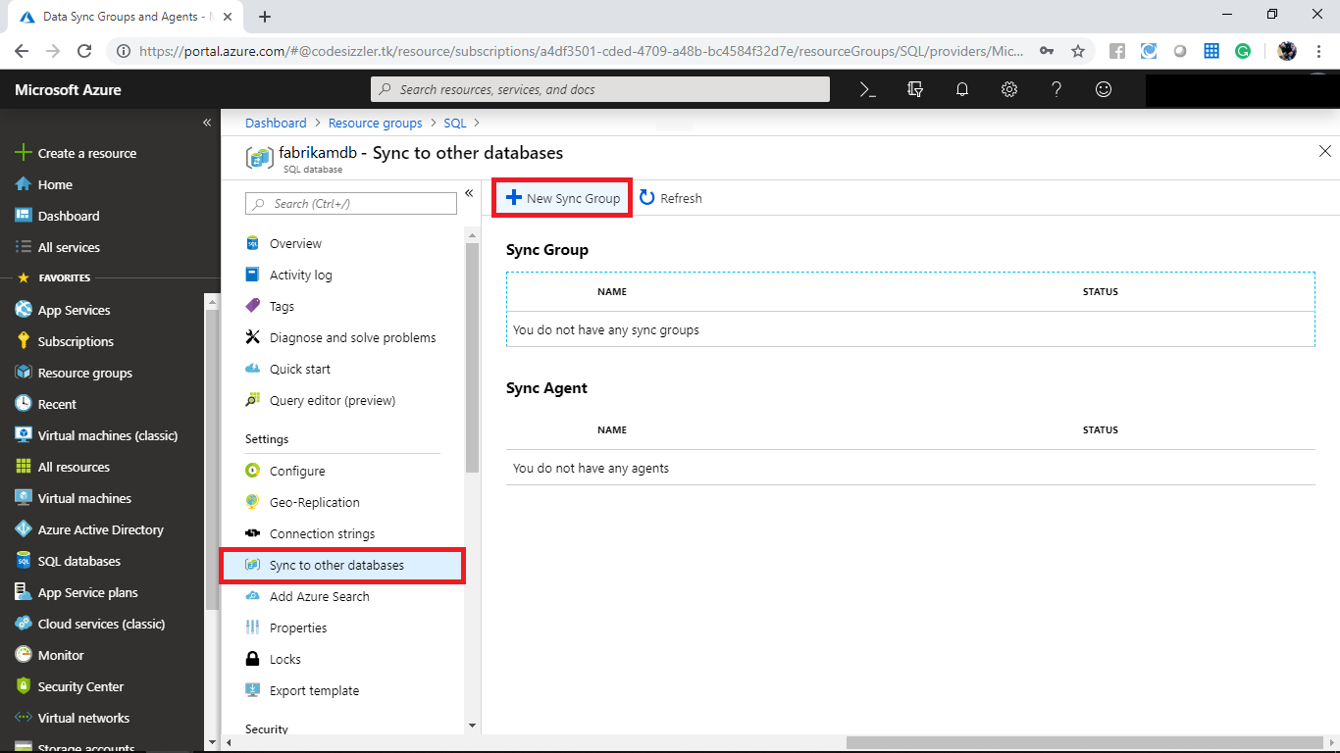

Add a sync group with following settings

* Create sync group
* Sync group name: fabrikamsyc
* Sync metadata database: New
* Automatic sync: On
* Conflict resolution: HubWin
* Add sync members

Click on add an Azure database and provide the following configurations

* Sync Member name: FabrikamMember
* Subscription: Select a valid one
* Azure SQL Server: fabrikamserver
* Azure SQL Database: fabrrikamdb
* Sync directions: To the Hub
* User name: FabrikamUser
* Password: For your choice
* Configure sync group
* Search for **Hub Database** and select all the results appear

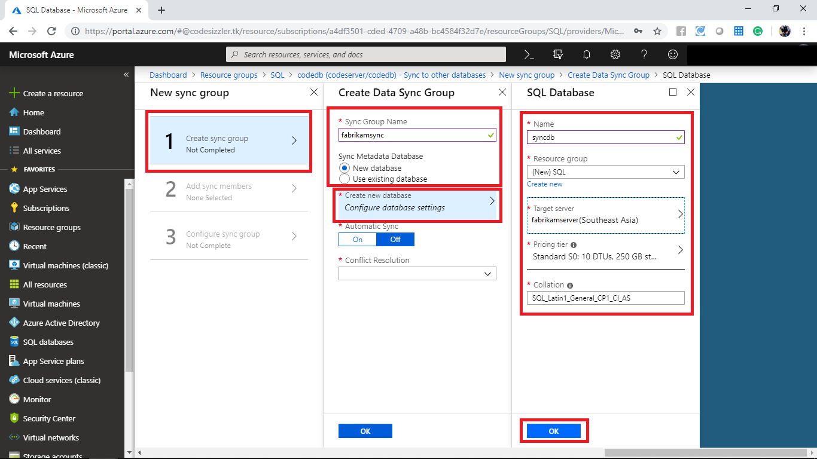

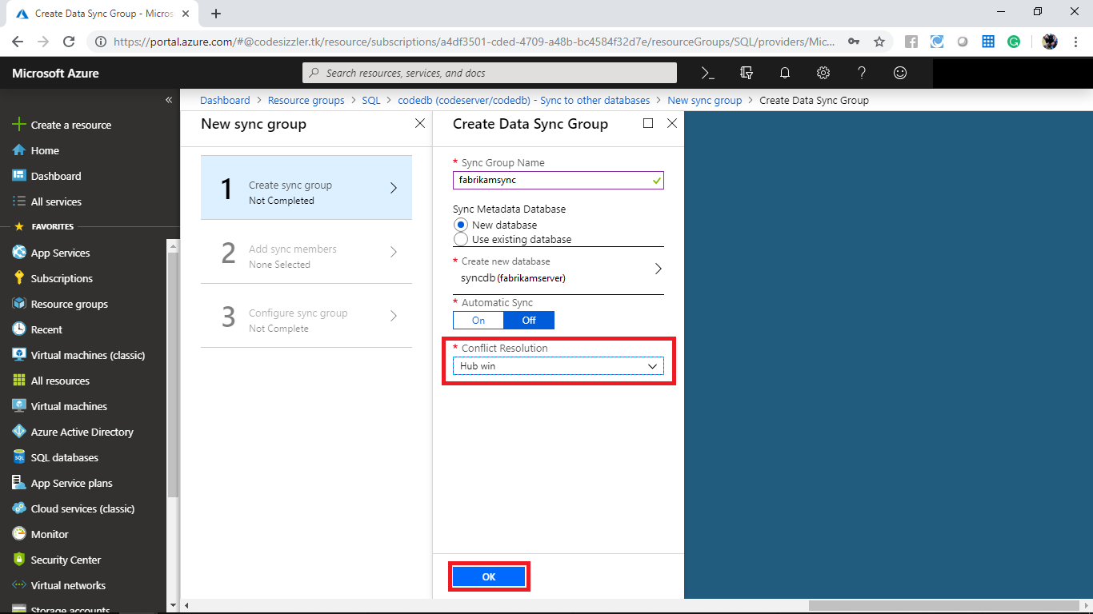

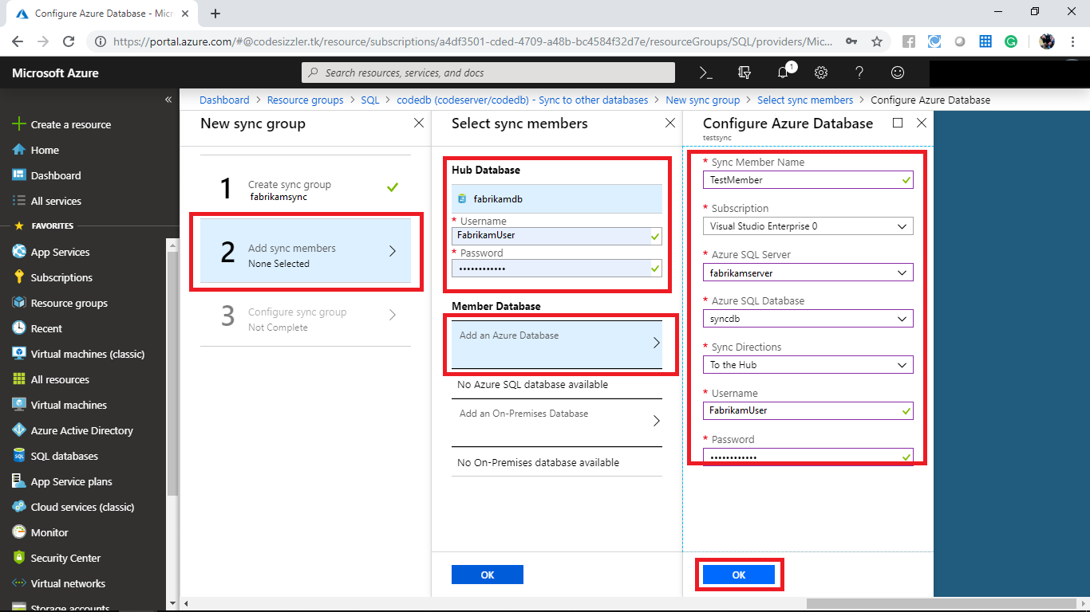

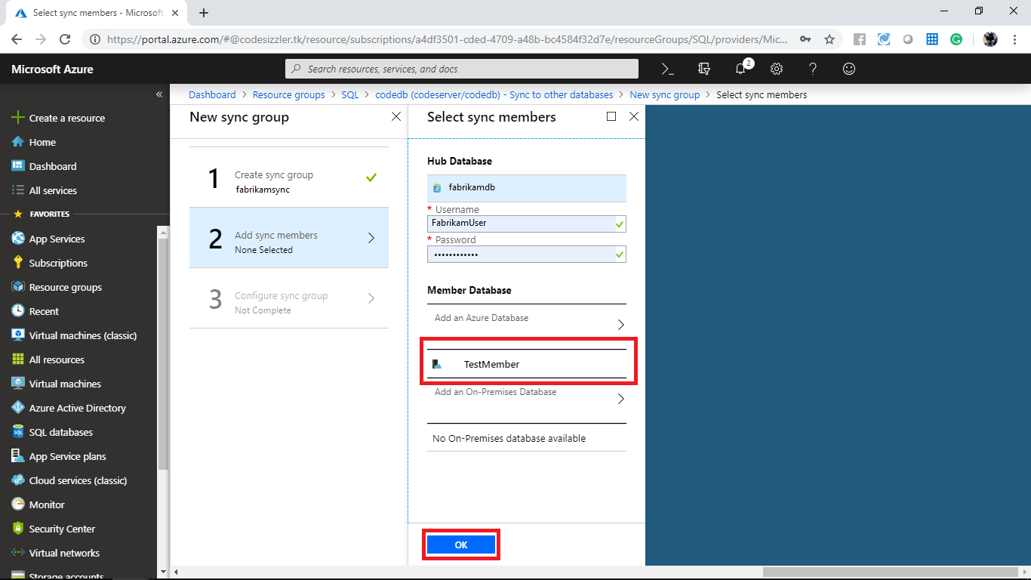

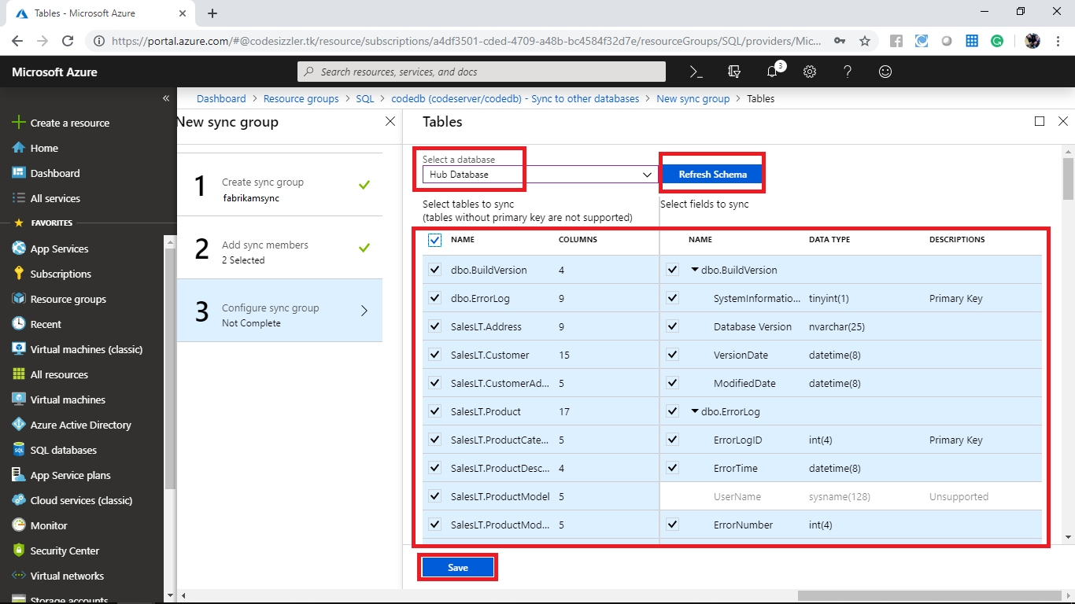

Navigate to **fabrikamsync** and click on the sync icon to sync the databases.

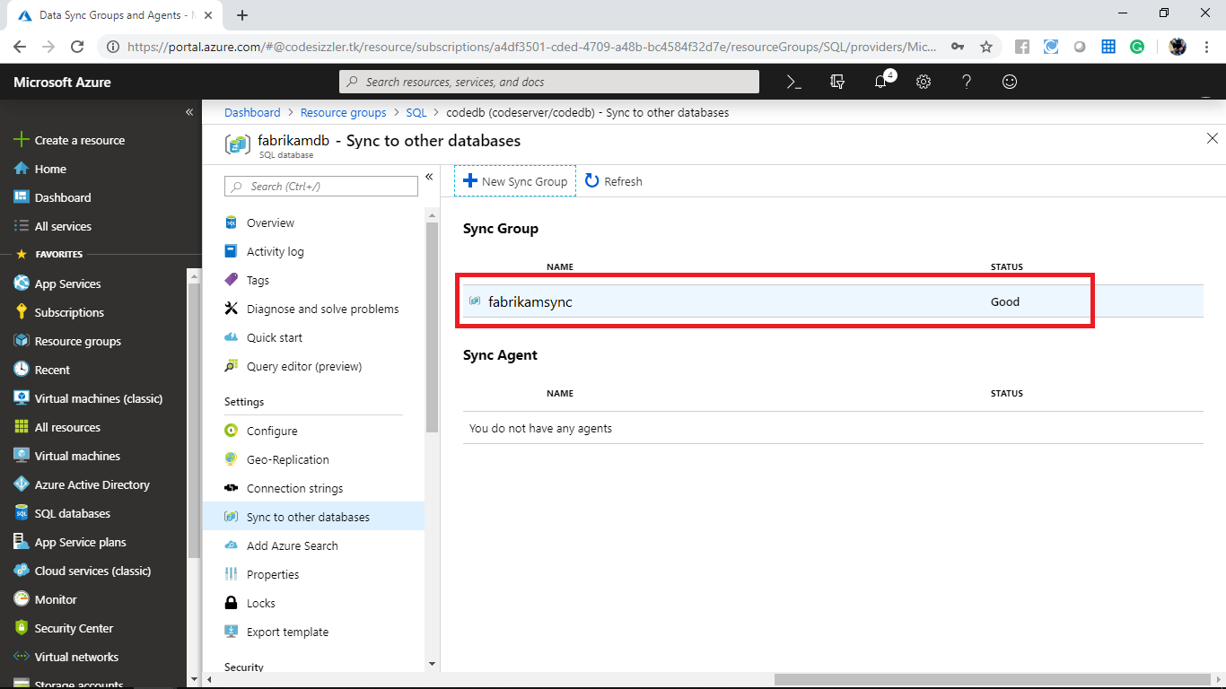

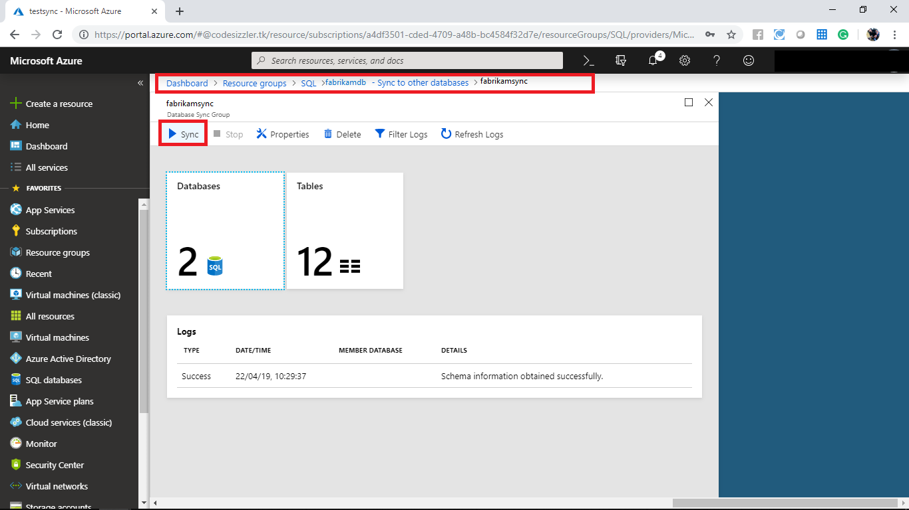

In Azure portal click on SQL Database from the left side menu and click on **fabrikamsync**.

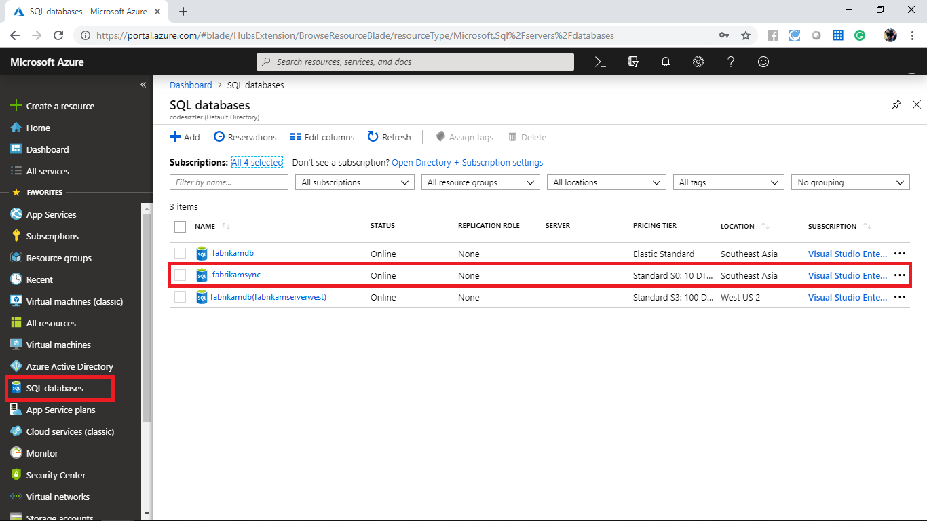

In the fabrikamsync panel click on **Query editor (Preview)**.

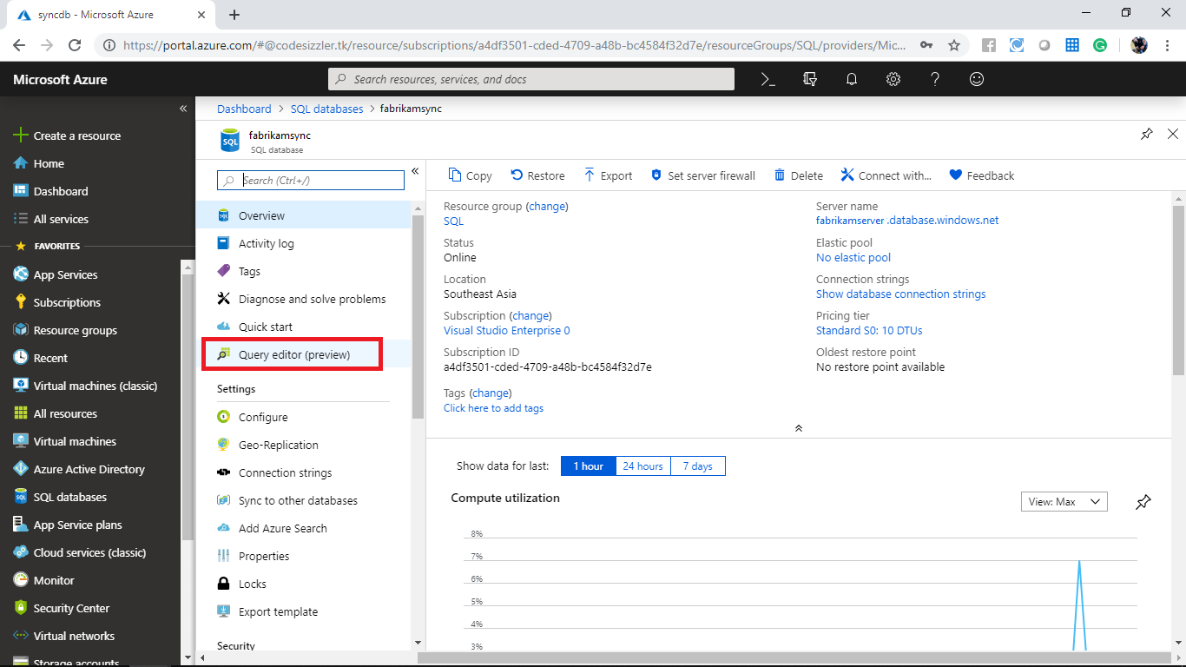

When it prompts provide the credentials which you have provided during the deployment and click on ok.

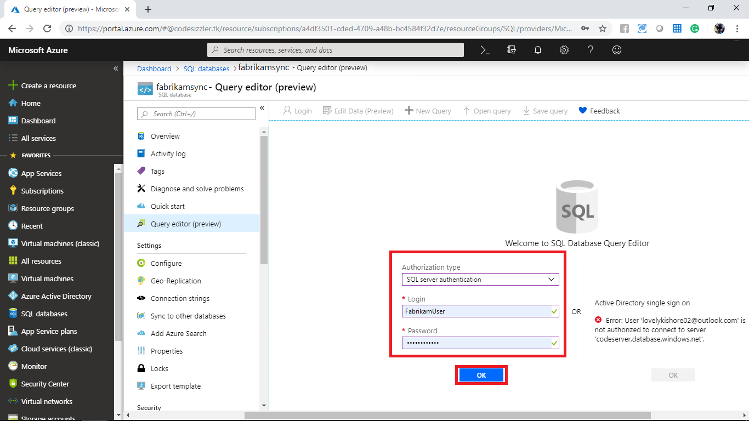

Monitor the list of databases synced.

